Laptop Price Prediction System

Contributors

M. Kalyan Kumar

Date: 09-09-2024

Problem Statement:

In today's competitive tech market, consumers face a wide range of laptop options with varying specifications and price points. Understanding how various factors such as processor type, RAM, storage, brand, and other features affect the price of a laptop is critical for both buyers and manufacturers. However, predicting the price of a laptop based on its specifications is a complex task due to the large variety of configurations and constant technological advancements.

Market Need Assessment:

**1. For Consumers:**

* **Price Transparency:** Consumers often find it challenging to compare laptop prices across different brands and configurations. A price prediction model provides transparency by helping them understand the fair price of a laptop based on its features.
* **Informed Decision-Making:** The model can help consumers identify laptops that offer the best value for their budget and requirements. It will empower them to make smarter purchasing decisions.
* **Cost-Effectiveness:** It reduces the risk of overpaying for a laptop by providing accurate price estimates, ensuring consumers get good value for their money.

**2. For Manufacturers and Retailers:**

* **Pricing Strategy:** Manufacturers can leverage the insights from the model to set competitive prices for their products. It helps them understand how specific features (like processor speed, brand, etc.) impact consumer perception of value and price.
* **Demand Forecasting:** By analysing market trends and predicting prices, manufacturers can better forecast demand for certain configurations, optimizing their production and inventory management.
* **Market Segmentation:** Manufacturers can tailor their product lines to different market segments based on price sensitivity and feature preferences. This model can help identify which features are more desirable for different pricing tiers.

**3. For E-commerce Platforms:**

* **Personalized Recommendations:** E-commerce platforms can use the model to recommend laptops to users based on their preferences and budget, improving customer satisfaction.
* **Dynamic Pricing:** By integrating the prediction model, platforms can adjust prices dynamically in response to market demand and competition, maximizing sales and profitability.

External Research:

Dataset: [Kaggle](https://www.kaggle.com/datasets/jacksondivakarr/laptop-price-prediction-dataset)

Regression Analysis

RandomForestRegressor Algorithm

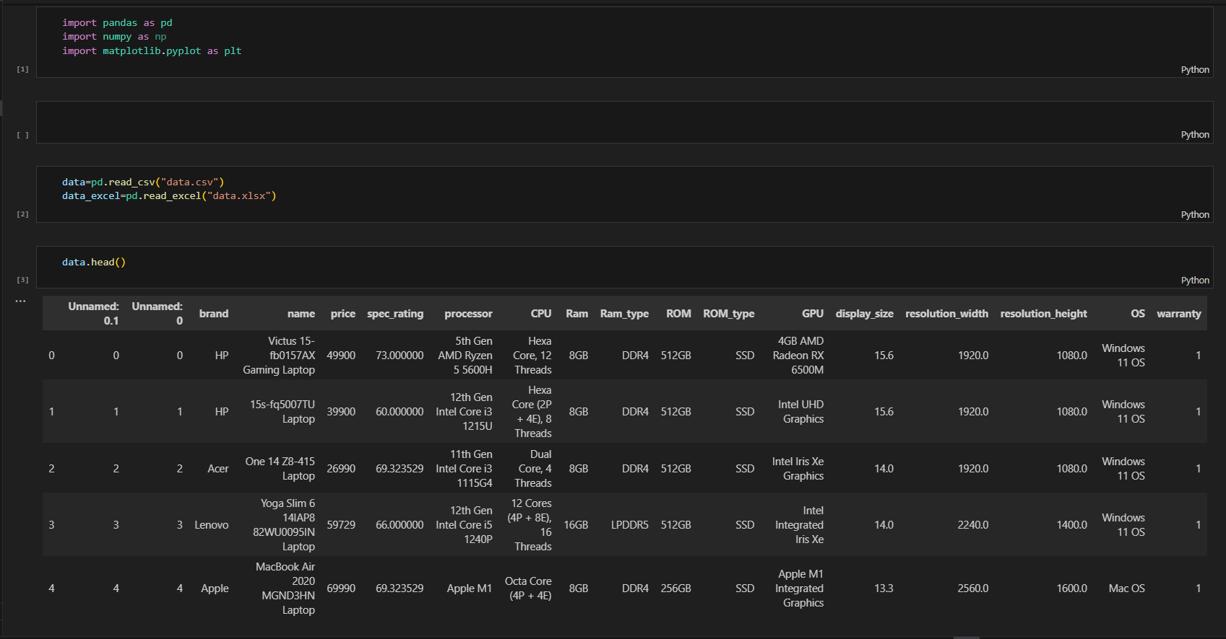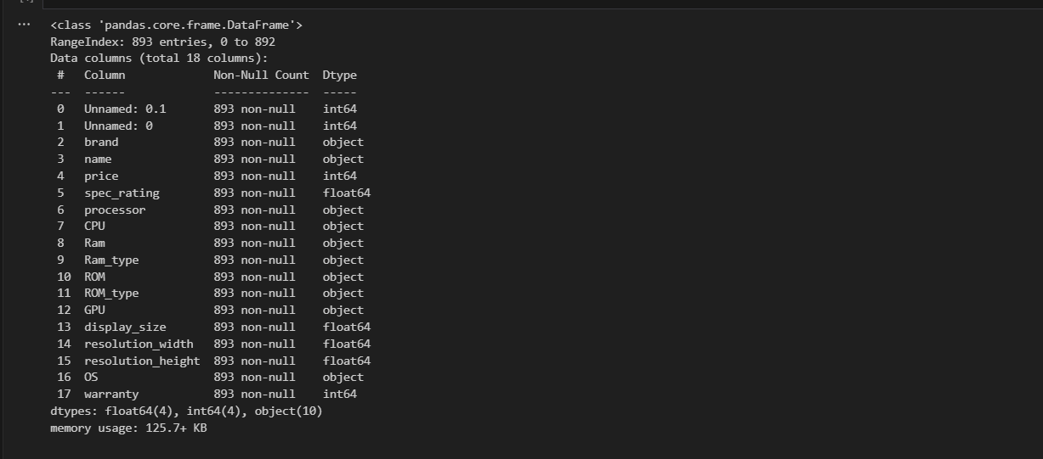Importing Dataset

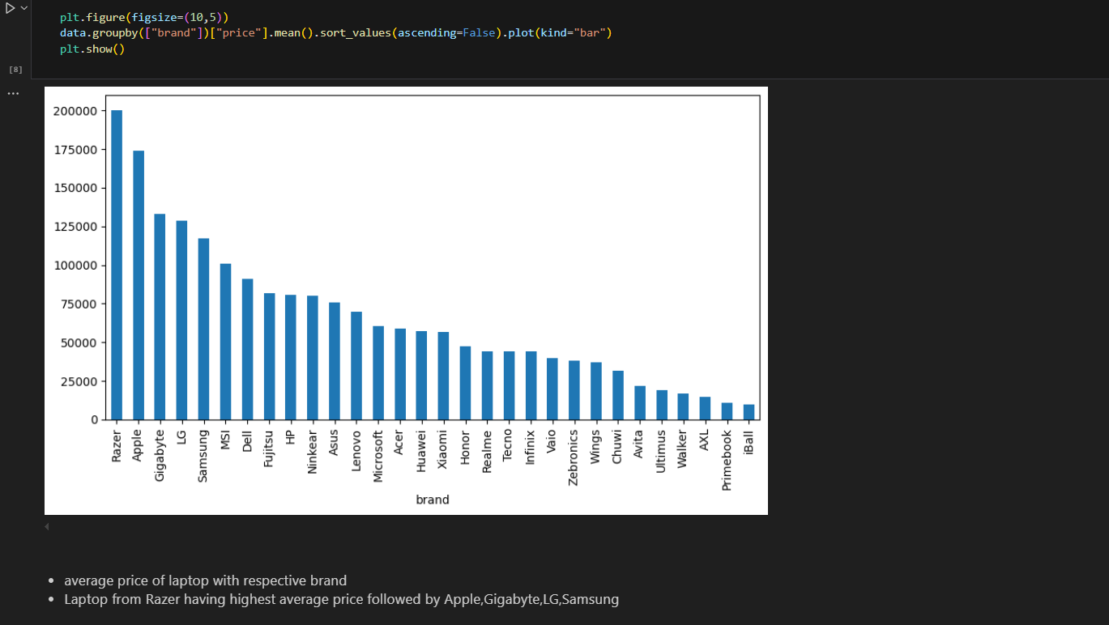Exploratory Data Analysis

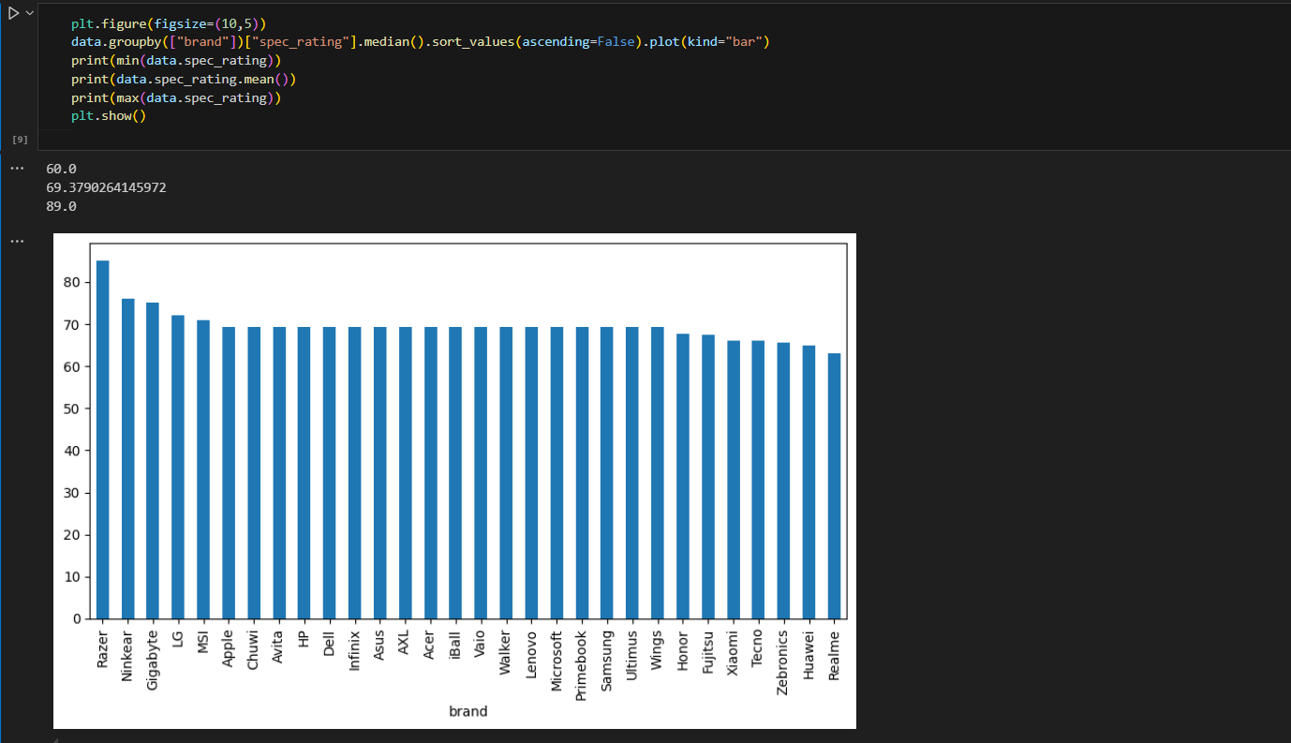

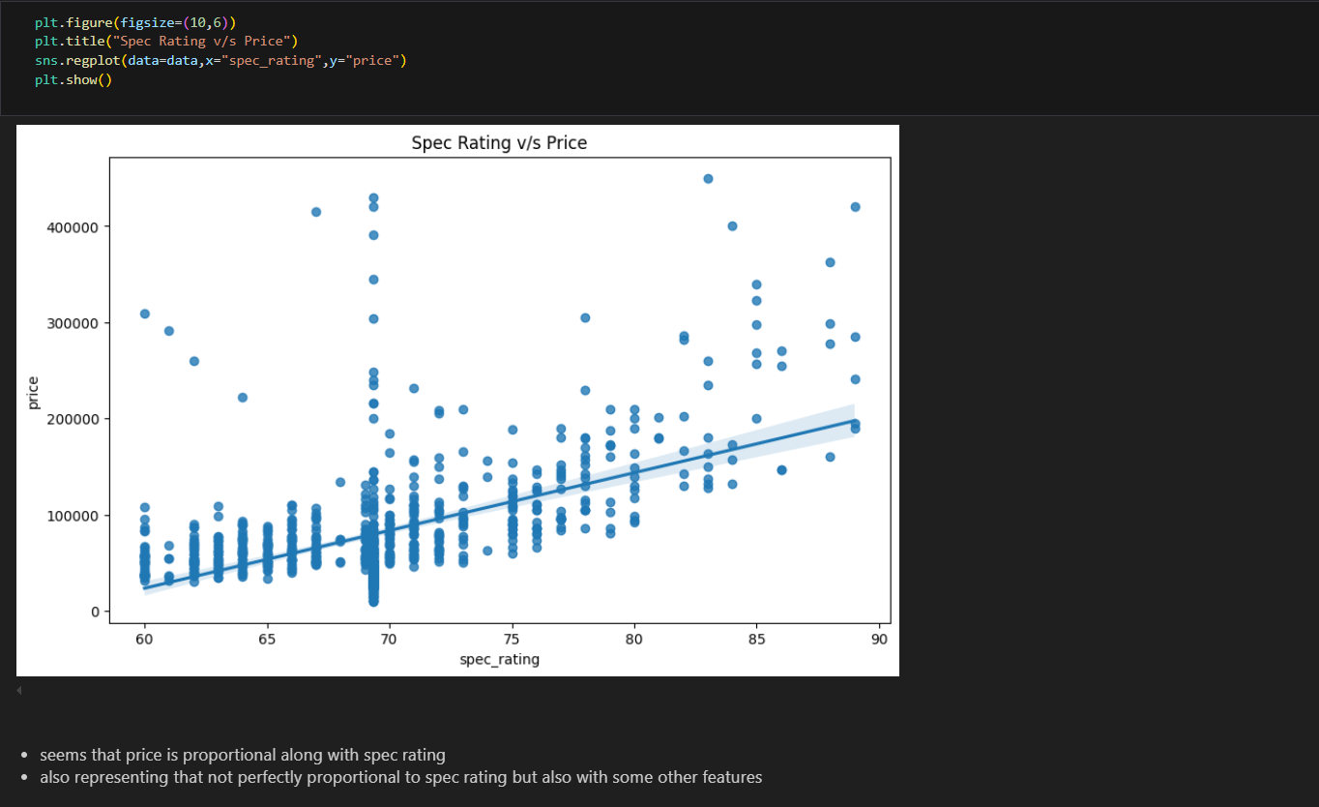

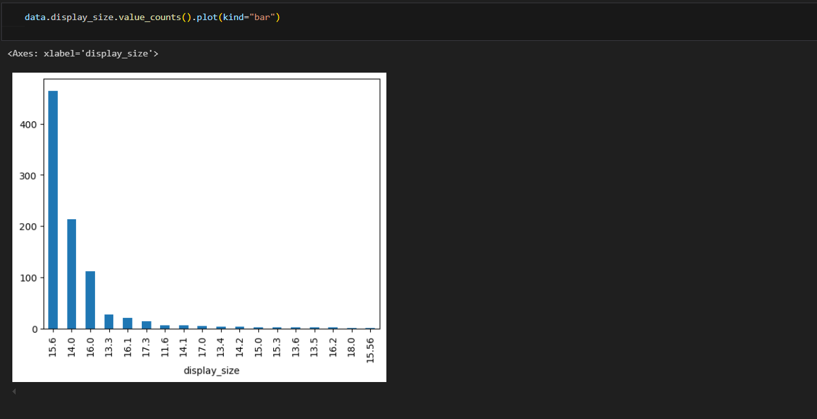

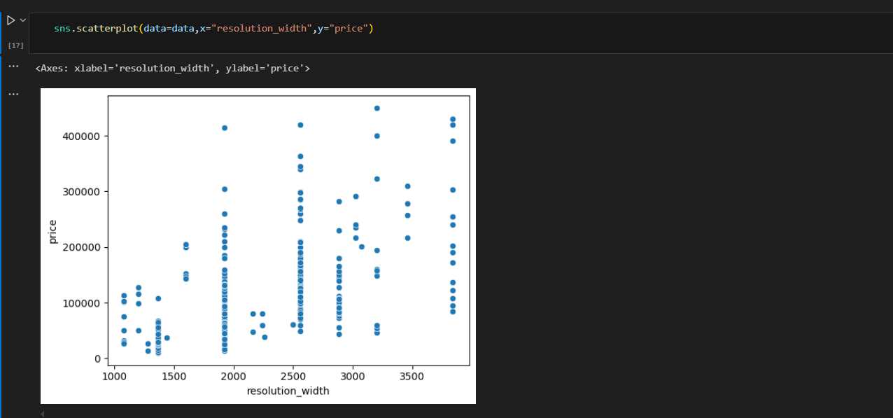

Data Preprocessing and Feature Engineering

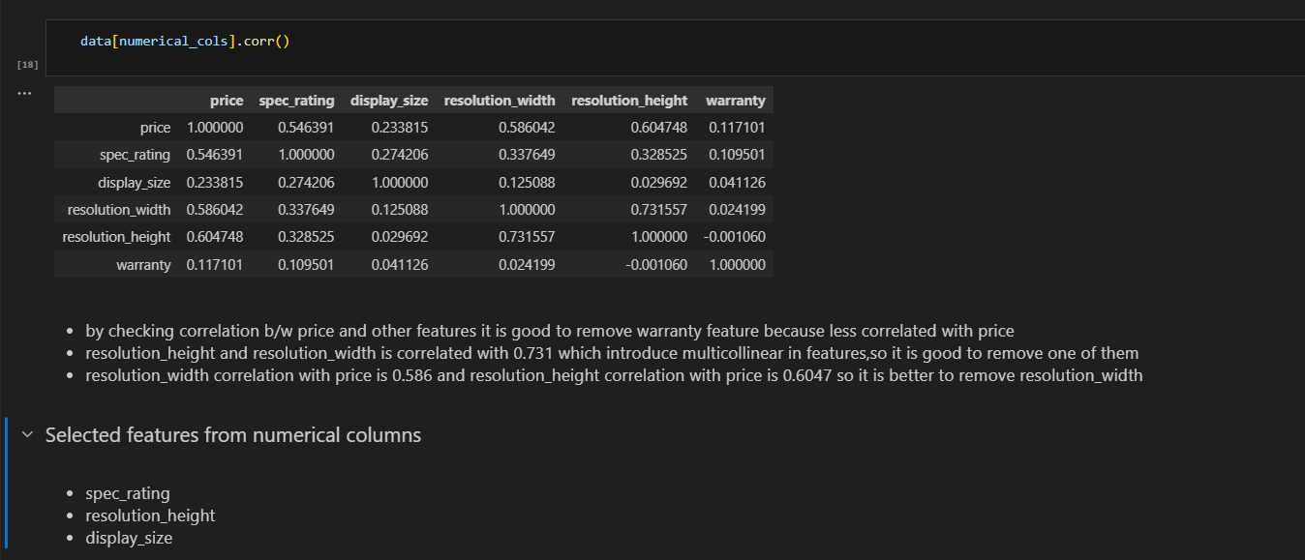

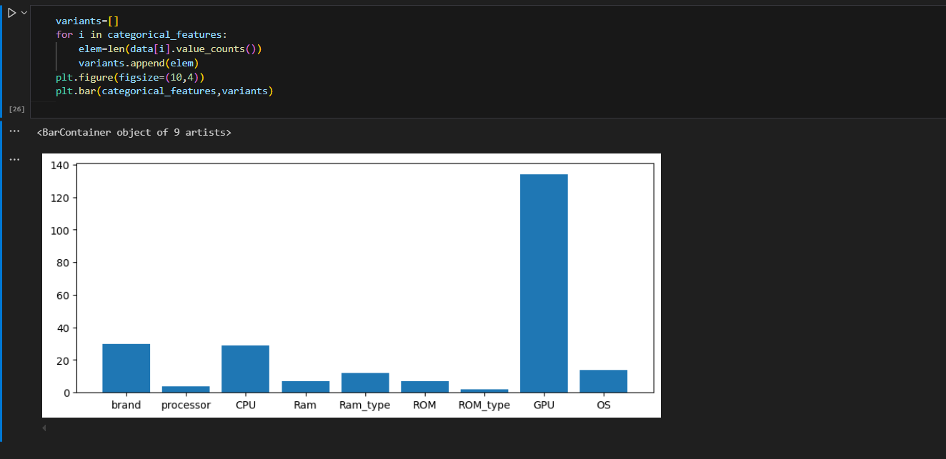

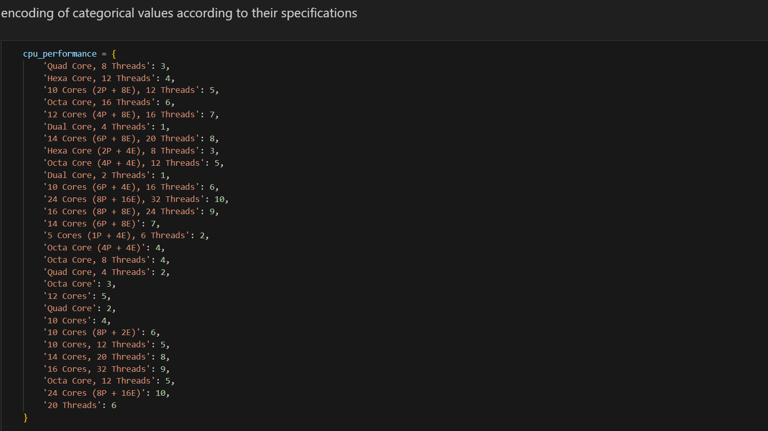

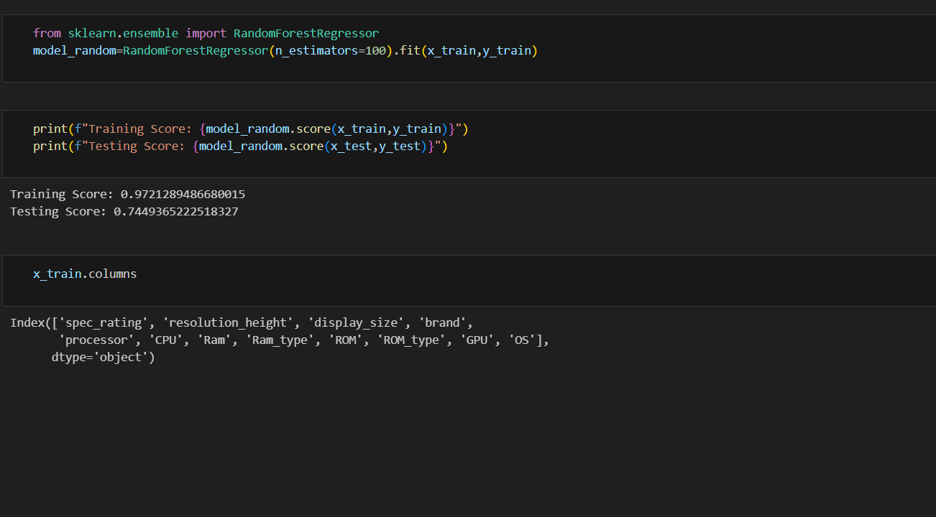

**Financial Equation for Laptop Price Prediction**

We can derive a price equation based on the most significant features that impact laptop price. Suppose the most important features are:

* **Processor** (categorical, indicating the type and generation of the CPU)
* **RAM** (numerical, representing memory size in GB)
* **Storage** (ROM size in GB)
* **GPU** (categorical, indicating the presence or absence of a dedicated graphics card)
* **Display Size** (screen size in inches)
* **Resolution**
* **Spec Rating** (a combined rating of laptop features)

A simplified **linear regression** model for predicting the price PPP based on these features could be:

P=β0+β1⋅Processor Rating+β2⋅RAM+β3⋅Storage+β4⋅GPU+β5⋅Display Size+β6⋅Resolution+β7⋅Spec